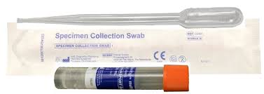Urine

1. Please do not urinate for at least one hour prior to sample collection
2. Open kit and remove orange topped tube. Discard specimen collection swab, it is not required.
3. 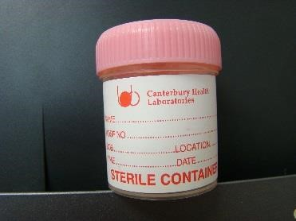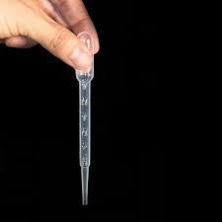Unscrew cap of collection pottle and collect the first part of urine stream (20-30mls).
4. Unscrew the orange tube cap taking care not to spill the liquid buffer in the tube.
5. Use plastic pipette to transfer urine from collection pottle into orange top tube. Ensure the level in the orange top tube falls within the clear view window on the side of the tube. Screw orange lid firmly back on tube.
6. Screw lid firmly back on collection pottle and retain pottle in case of further tests being required. Discard transfer pipette.
7. Fully label collection pottle and orange top tube with identification details and time/date of collection.
8. Place samples in specimen collection bags and return as instructed by care provider.

**PLEASE LABEL ALL SAMPLES AND MAKE SURE THE LIDS ARE FIRMLY CLOSED**