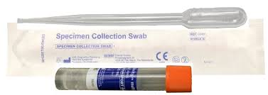Rectal Swab

1. Open kit and remove orange topped tube. Discard transfer pipette, it is not required.
2. Remove the sterile swab from the wrapper, taking care not to touch swab tip or lay it down on any surface.
3. 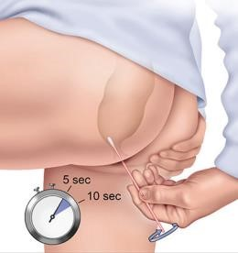Carefully insert the swab into your rectum about 2.5cms and gently rotate the swab for 5 to 10 seconds.

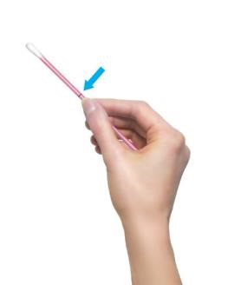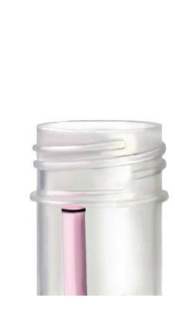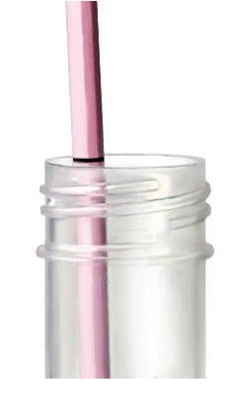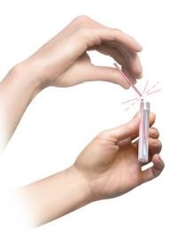

1. While holding the swab in hand, unscrew the tube cap.
2. Withdraw the swab and place it into the transport tube so the white tip is down.
3. Carefully break the swab at the scored line on the shaft; use care to avoid splashing of contents.
4. Label the transport tube with name/identifier and the date/time of collection.
5. Place tube in specimen bag and return tube as instructed by the care provider.

**PLEASE LABEL ALL SAMPLES AND MAKE SURE THE LIDS ARE FIRMLY CLOSED**