|  |
| --- |
| Faeces Collection |
| **Patient Information** |

Your doctor has requested a sample of faeces to be sent to the laboratory for examination.

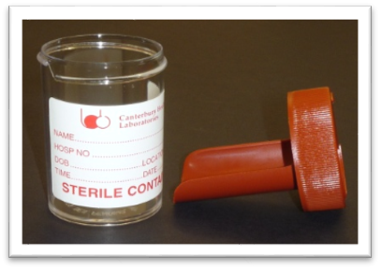Please use the brown plastic top container with scoop spoon (pictured below) that you have been supplied.

1. Collect a sample in a large clean plastic container

2. The amount of faeces sample we need for testing is about the size of a whole walnut

3. Use the scoop spoon supplied to transfer a sample into the smaller, brown top, container

4. Label the specimen jar with your name, date of birth, and the date the sample was taken

5. Take the sample to the laboratory on the **same day as collection**

Multiple samples

If more than one sample is requested, then please collect them on separate days and bring them into the laboratory on each separate day. Please do not split a single sample.

Contact information

Christchurch: for a full list of collection centres and their opening hours please visit www.bloodtest.co.nz or contact 0800 THE LAB (843522) ext. 86647

Ashburton: CHLabs, Ashburton Hospital, Elizabeth Street, Ashburton, 03 307 8456

For more information about:

* hospital and specialist services, go to [*www.cdhb.health.nz*](http://www.cdhb.health.nz)
* your health and medication, go to [*www.healthinfo.org.nz*](http://www.healthinfo.org.nz)