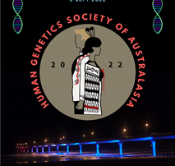
HUMAN GENETICS SOCIETY OF AUSTRALASIA (NZ BRANCH) MEETING

Friday 2nd September 2022 in Christchurch
Decoding Aotearoa
Abstract Submission Form
Instructions: Please complete the box below with your abstract submission.
TITLE IN CAPITALS, Arial font size 12pt. Authors and affiliations abbreviated, include email addresses. Presenting author underlined. Unstructured, no references, 250 word limit. Submission Deadline Monday 1st August 2022. All submissions are for a 20 minute oral presentation.

Corresponding Author
Name:
Address:

Phone:
Email:
Submit by email to genelab.test@cdhb.health.nz on or before 1st August 2022

